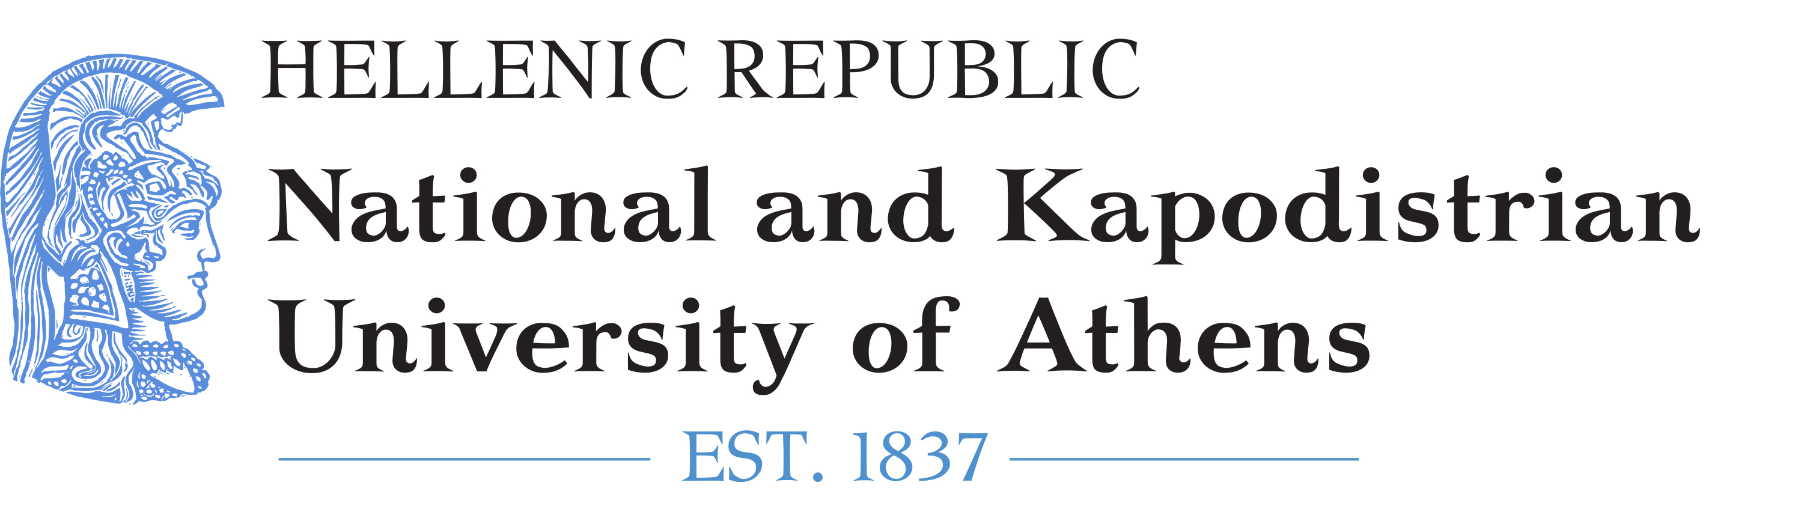

INVITATION
Upon the occasion of the Annual Meeting in Athens of the Editors-in-chief of the Yearbook of International Environmental Law,
Athens PIL is honoured to invite the LL.M. class 2018 to a general discussion on environmental law with
- Professor Timo Koivurova, Director of the Arctic Center, University of Lapland
- Professor Bharat H. Desai, Jawarhalal Nehru University, New Delhi
- Ass. Professor Maria Gavouneli, National & Kapodistrian University of Athens, and
- Ms Grace Ranola, Associate Publisher, Oxford University Press
on Thursday, 7 June 2018 at 4.30pm in the gardens of the Faculty Club, Kostis Palamas Building, Academias 48.

www.athenspil.law.uoa.gr

