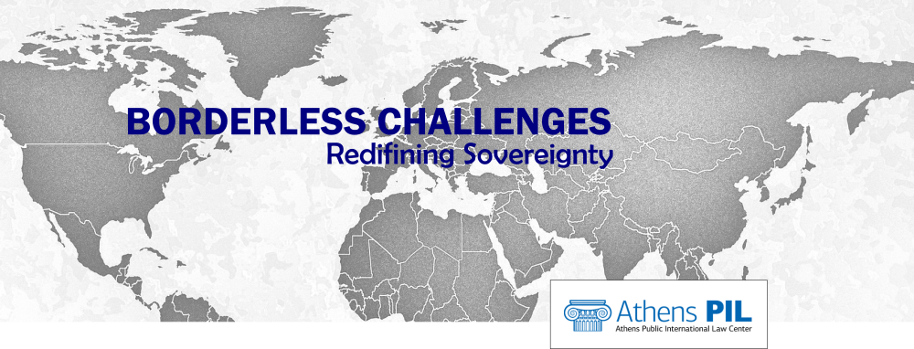
Round Table
“Controlling Immigration beyond the External Borders of the EU”
AthensPIL, Academias 47, 10672 Athens
2 December 2021 at 17.00 – 19.00

Moderator:
Professor Maria Gavouneli, National and Kapodistrian University of Athens

Presentation of research findings (Borderless Project):
Dr. Maria-Louiza Deftou, Fellow Athens PIL
Dr. Dimitra Papageorgiou, Fellow Athens PIL
Eva Tzavala, Researcher Athens PIL

Discussing:
Recent trends in legal pathways to migration, Konstantinos Farmakidis-Markou, Human Rights Lawyer
Externalisation of migration control vs Instrumentalisation of migrants at borders, Dr. Markos Karavias, Special Adviser to the Minister of Migration and Asylum for the EU Pact; Former Director, Greek Asylum Service
Migration control and maritime security: novel threats, Dr. Efthymios (Akis) Papastavridis, Fellow Athens PIL; Researcher in Law of the Sea and Part-time Lecturer at the Faculty of Law of University of Oxford [zoom]

